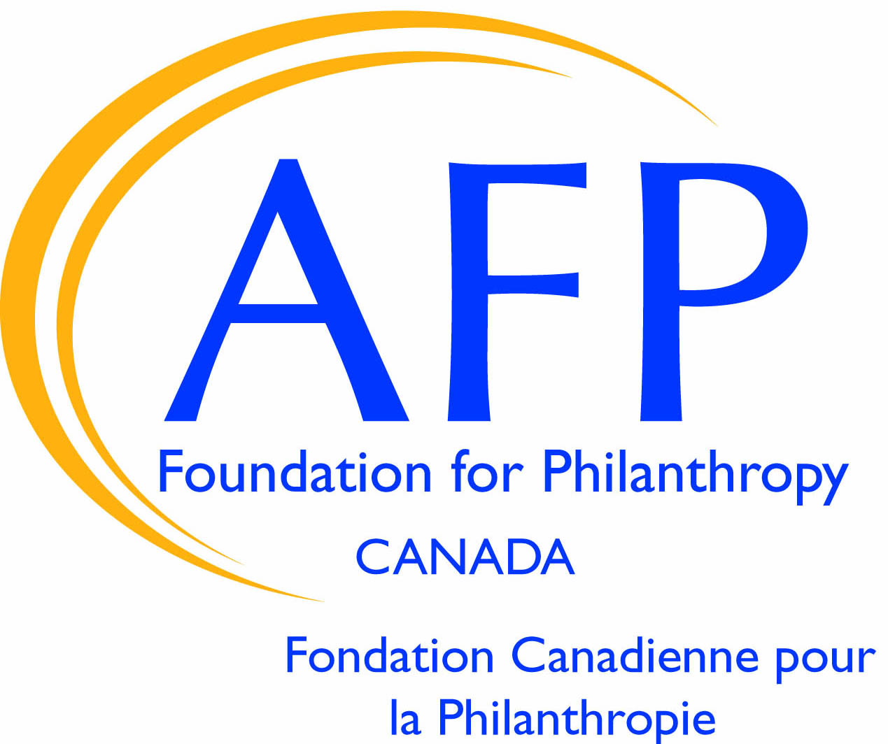
Job Description

Position: Director, AFP Foundation for Philanthropy - Canada Date: Oct 2024
Reports to: EVP Foundations for Philanthropy, AFP Global Status: Canada Staff
Department: Foundations
Budget: $60,000 - 65,000 plus HST – 20 hours per week

Position Summary
The Association of Fundraising Professionals Foundation for Philanthropy – Canada (AFP Foundation), a registered charity, is seeking a half-time Director, contract position, to lead fundraising and operations in partnership with the volunteer Board and committees.

The AFP Foundation was founded in 2000 to raise funds to further the fundraising profession in collaboration with AFP Canada and AFP Global. Since its founding it has funded critical research, life-changing scholarships, and programming to fundraisers across Canada. Now that the founding staff partner is retiring, the Foundation is seeking its next leader to build on this momentum. As Director, this position is responsible for strategic governance, ensuring that day-to-day operations are managed, and raising funds to advance the profession.

The incumbent Director will bring a strong understanding or a willingness to learn about the principles of inclusion, diversity, equity and access (IDEA). This is a core principle and a priority for the AFP Foundation.

Accountability
The Director is directly responsible to the AFP Foundations for Philanthropy Executive Vice President (EVP) located in the United States for the effective strategy, administration and proper fulfillment of all functions of the position. The Director is held to performance objectives and metrics established by the EVP in collaboration with the AFP Foundation Board Chair(s).

One Development Associate (located in Canada) reports to the Director.

Major Responsibilities
Leadership
- Provide leadership and direction for all aspects of fundraising operations, strategic initiatives, and processes. This includes setting and monitoring strategic goals and developing the corresponding fundraising campaigns in line with the organization’s mission and priorities.
- Support the Board of Director’s nominations process, committee composition, and meeting preparation.
- Manage one staff member (full-time Development Associate) located in Canada.
- Ensure appropriate connection with AFP Canada through the AFP in Canada Strategic Plan as well as operations plan.
- With AFP Canada staff partner and AFP Foundations for Philanthropy Executive Vice President, act as conduit with AFP Global to share strategic visions, opportunities, and challenges.

Fundraising
- Create and lead overall resource development strategies for individuals, corporations, agencies, and foundations, including major prospect cultivation, planned giving, and resource development events.
- Develop fundraising forecasts and budgets.
- Oversee cultivation and maintenance of contacts with funding entities and individuals.
- Serve as an external ambassador and make direct major gift solicitations and presentations on behalf of the organization.
- Work closely with volunteer Board members and Committees to achieve AFP Foundation goals.
- Coordinate and develop proposals and follow-up either independently or in concert with volunteer committees and staff.
- Liaise with prospective, current and past major donors to the Foundation, and coordinate Board Member stewardship of donors.
- Nurture relationships to guarantee sustained commitment from donors, partners, and funders, fostering amplified support for the Foundation’s mission.
- Produce appropriate stewardship materials for selected contributors and deliver as needed.
- Develop and supplement prospect research as required.
- Coordinate, prepare, document and attend (virtually) Board and Committee meetings.

Administration
- Maintain the organizational and administrative capacity and structure of the AFP Foundation to accomplish the strategic goals established by the Board.
- Ensure that all legal requirements are met on an annual basis.
- Ensure that all accounting requirements are met on an annual basis, including budget preparation, audit and monthly financial statements.
- Provide oversight for the annual fund and major gift fundraising goals.
- Ensure that communication and receipts for donors are accurate and timely.
- Ensure that program delivery is implemented for scholarships, research and educational offerings.

Knowledge, Skills, and Abilities
- Fundraising - Documented success in raising funds.
- Inclusive Leadership - An outstanding manager/leader with a demonstrated commitment to collaborating with and motivating a diverse range of people.
- Strategic Relationship Building – Strong partnership skills that generate the resources necessary to support the AFP Foundation’s mission.
- Financial - Expertise in financial management, proposal development, accounting and budgeting.
- Results-Driven – Dedicated to shared and measurable goals for the common good, creating, resourcing, scaling, and leveraging strategies and innovations for broad investment and impact.
- Effective and Engaging Communicator/Listener – Confidence to articulate the Foundation’s message in a way that inspires others to act in service to the Foundation’s and the community. Strong active listening skills.
- Planning and Implementation – Is a leader and takes initiative in planning and developing initiatives within impact areas to achieve results that drive collective community outcomes.
- Planning - Experience in environmental scanning and strategic planning.
- Boards - Experience working with governing boards and boards of directors.

Guidelines
Requirements include:
- Location is flexible, as long as respondent is located in Canada;
- Attend at least one in-person meeting in July in conjunction with the AFP in Canada Leadership Retreat;
- Valid passport to travel to the AFP Global head office in Virginia, United States and/or the annual AFP ICON conference held in North America;
- Provide up to 20 hours per week for the above role;
- Manage one staff member responsible for data entry and administration.

Education, Experience, and/or Training Requirements:
- Bachelor of Arts or Bachelor of Science Degree - in a field aligned with philanthropy, fundraising, and non-profit administration (i.e. public relations, public administration, communications) - preferred.
- Certified Fundraising Executive (CFRE) preferred.
- Bilingualism is an asset, but not required

Employment Equity Statement
The original stewards of Turtle Island, also known as Canada, are the Indigenous peoples of this territory. The Association of Fundraising Professionals (AFP) in Canada acknowledges the important relationship Indigenous peoples have with this vast space and the devastating legacy of colonization on their communities and the land we all occupy today.
AFP in Canada is committed to understanding the history and current realities of our diverse profession, including Indigenous, racialized and equity-deserving groups across the charitable sector. We acknowledge that the ongoing process of inclusion and reconciliation involve a review of the common practices that inform how Canadian charities value generosity and reciprocity. New paradigms, founded on principles of respect, allyship and justice, hold great potential in transforming the sector.
As such, AFP Foundation is committed to finding a leader that shares these values.

