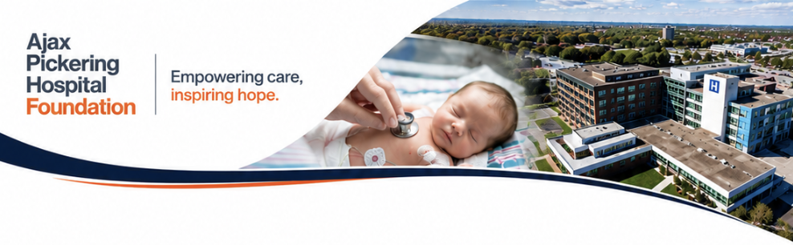

Graphic Design & Marketing Officer
Ajax Pickering Hospital Foundation
Full-Time

Position Summary
Ajax Pickering Hospital Foundation is seeking a highly creative, ambitious, and execution-focused Creative & Marketing Officer to help shape how we engage donors, tell stories, and inspire philanthropy across our community.
This is not a traditional communications coordinator role. Reporting directly to the Foundation CEO, this position is a strategic, hands-on creative leadership role responsible for leading the Foundation’s in-house design, visual storytelling, and marketing execution across fundraising campaigns, donor communications, events, digital marketing, and hospital lottery initiatives.
The successful candidate will combine exceptional graphic design ability with modern marketing instincts, donor-focused storytelling, and strong digital execution skills. They will thrive in a fast-paced, entrepreneurial environment where creativity, innovation, collaboration, and mission-driven work are deeply valued.
This role is ideal for a creative professional who wants to build meaningful campaigns that directly impact healthcare in our community.

Key Responsibilities

Creative & Brand Leadership
- Lead the development and execution of all in-house creative materials for the Foundation
- Design compelling donor-facing materials that inspire philanthropy and community engagement
- Create visually impactful fundraising campaigns across print and digital channels
- Develop campaign branding, creative concepts, and visual storytelling strategies
- Ensure brand consistency across all communications and marketing initiatives
- Continuously evolve and strengthen the Foundation’s visual identity and creative presence

Fundraising, Lottery & Event Marketing
- Lead creative development for hospital lottery and raffle campaigns
- Design high-performing creative assets across digital, print, email, social media, outdoor advertising, and direct mail channels
- Create direct mail appeals, donor stewardship materials, annual reports, impact pieces, newsletters, and fundraising collateral
- Develop event branding including signage, presentations, invitations, sponsor recognition materials, and promotional assets
- Support donor acquisition and campaign performance through compelling storytelling and donor-focused creative
- Coordinate with external vendors, printers, agencies, photographers, and production partners as required

Digital Marketing & Website Management
- Build and maintain website pages, campaign landing pages, and digital fundraising assets
- Manage website content using WordPress or other CMS platforms
- Design digital creative for:
  - Email marketing campaigns
  - Social media
  - Paid advertising
  - Online fundraising initiatives
  - Donor engagement campaigns
- Support digital advertising campaigns with creative optimized for engagement and conversion
- Monitor evolving digital trends and recommend innovative approaches to audience engagement

Photography, Video & Content Creation
- Capture and edit basic photography and video content for campaigns, events, donor stories, and social media
- Create short-form video and multimedia content for fundraising and marketing initiatives
- Support storytelling efforts that connect donors emotionally to healthcare impact and patient care

Collaboration & Project Management
- Work collaboratively with fundraising, events, communications, and leadership teams
- Manage multiple concurrent projects with competing deadlines in a fast-paced environment
- Coordinate project timelines, approvals, and production schedules
- Ensure all projects are delivered on time, on brand, and to a high standard of quality

Qualifications & Skills

Required Qualifications
- Diploma or degree in Graphic Design, Marketing, Communications, Digital Media, or a related field
- Minimum 3–5 years of progressive experience in graphic design, creative services, marketing, or digital communications
- Demonstrated experience producing high-quality creative across print and digital channels
- Strong portfolio showcasing campaign work, branding, digital marketing, print design, and storytelling
- Exceptional visual design skills and attention to detail
- Strong organizational skills and ability to manage multiple priorities in a deadline-driven environment

Preferred Qualifications
- Experience working in healthcare, non-profit, philanthropy, agency, or mission-driven organizations
- Experience supporting fundraising campaigns, donor communications, or direct response marketing
- Hospital lottery or raffle campaign experience considered a significant asset
- Knowledge of accessibility standards and inclusive design practices
- Familiarity with healthcare philanthropy and donor engagement strategies

Technical Skills
The ideal candidate will demonstrate strong proficiency in some or all of the following:
- Adobe Creative Suite (InDesign, Photoshop, Illustrator)
- Canva
- WordPress or website CMS management
- Email marketing platforms such as Mailchimp, HubSpot, or Constant Contact
- Social media content creation and digital campaign execution
- Print production and vendor coordination
- Basic photography and videography
- Video editing software such as Premiere Pro or equivalent
- Microsoft Office and presentation design

Personal Attributes
We are looking for someone who is:
- Highly creative with strong visual judgment and storytelling instincts
- Entrepreneurial, proactive, and solutions-oriented
- Comfortable working in a fast-moving, evolving organization
- Collaborative and relationship-driven
- Adaptable, organized, and calm under pressure
- Passionate about healthcare, philanthropy, and community impact
- Motivated by meaningful work and mission-driven storytelling

Why Join Ajax Pickering Hospital Foundation?
This is an opportunity to help shape the future of a growing healthcare philanthropy organization making a direct impact on patient care and healthcare in our community.
You will join a high-performing, entrepreneurial team that values creativity, innovation, collaboration, and bold thinking. We are building an in-house creative and marketing function designed to move quickly, think differently, and create meaningful campaigns that inspire donor action and community engagement.
You will have the opportunity to:
- Lead creative work that directly impacts fundraising success
- Build integrated campaigns with visible community impact
- Work closely with senior leadership
- Bring fresh ideas and innovation to healthcare philanthropy
- Help modernize and elevate a growing foundation brand
- Contribute to life-changing healthcare initiatives in our region

Compensation & Benefits
Salary Range:
$70,000 – $85,000 annually
(commensurate with experience and portfolio strength)
Comprehensive benefits package including:
- Extended health and dental coverage
- 3 weeks’ Vacation
- Professional development opportunities
- Meaningful mission-driven work with visible community impact

Application Process
Interested candidates are encouraged to submit:
- Resume
- Cover letter
- Portfolio of recent creative work
Please submit to Steven Cook at scook@lh.ca
Subject line: Graphic Design & Marketing Manager
Deadline: 5:00pm on 16th July 2026
