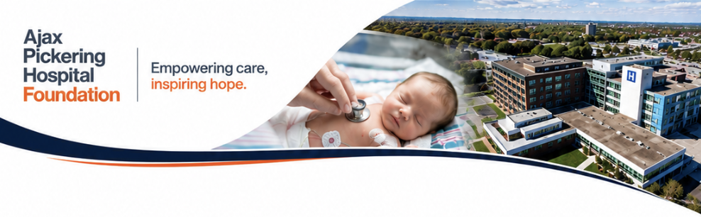

Senior Community Partnerships & Events Officer
Ajax Pickering Hospital Foundation
Full-Time

Position Summary
Ajax Pickering Hospital Foundation is seeking a highly motivated, relationship-driven, and entrepreneurial Senior Community Partnerships & Events Officer to join our growing fundraising team.
Reporting directly to the CEO, this position plays a critical role in driving fundraising growth through community engagement, corporate partnerships, sponsorship development, third-party fundraising initiatives, and signature fundraising events.
This is not a traditional event coordinator role. The successful candidate will primarily focus on generating revenue, building strategic community relationships, growing sponsorship opportunities, and expanding the Foundation’s community fundraising portfolio. Signature event management and execution will represent an important secondary component of the role.
The ideal candidate is a confident relationship builder who thrives in the community, enjoys networking and partnership development, and is energized by achieving meaningful fundraising results that directly impact healthcare in Durham Region.
This role is ideal for a highly collaborative and ambitious fundraising professional who wants to help grow a modern, community-focused healthcare philanthropy organization.

Key Responsibilities

Community Partnerships & Revenue Generation
- Grow and manage the Foundation’s third-party and community fundraising portfolio
- Identify, solicit, secure, and steward corporate sponsors, community partners, and fundraising supporters
- Build meaningful relationships with local businesses, service clubs, schools, sports organizations, community groups, and donors
- Develop new partnership and sponsorship opportunities that increase revenue and community engagement
- Serve as a visible and active ambassador for the Foundation throughout the community
- Represent the Foundation at networking events, community functions, and partnership meetings
- Develop and implement strategies to expand fundraising participation and sponsorship growth
- Support donor stewardship and recognition initiatives to strengthen long-term relationships
- Maintain strong relationships with event committees, volunteers, sponsors, and community stakeholders
- Track sponsorship and fundraising performance metrics and identify opportunities for growth

Signature Events & Community Fundraising
- Support the planning and execution of signature fundraising events including annual galas, golf tournaments, community campaigns, and donor engagement events
- Manage externally organized third-party fundraising initiatives benefiting the Foundation
- Coordinate sponsorship fulfillment, event logistics, volunteer engagement, and event timelines
- Collaborate with internal and external stakeholders to ensure successful event execution
- Assist with event budgeting, vendor coordination, auction procurement, and donor experiences
- Help create memorable community and donor engagement opportunities that strengthen the Foundation’s visibility and reputation

Relationship Management & Stewardship
- Provide exceptional stewardship to sponsors, donors, volunteers, and community partners
- Ensure timely follow-up, communication, and recognition for all supporters
- Collaborate closely with Foundation leadership, fundraising, and marketing teams to maximize fundraising outcomes
- Support integrated campaigns and community engagement initiatives across the organization
- Maintain accurate records, partnership activity, and donor interactions within CRM systems

Collaboration & Organizational Support
- Work collaboratively across fundraising, marketing, communications, and event initiatives
- Contribute ideas and strategies that support organizational growth and innovation
- Assist with Foundation activities and campaigns as required
- Support a collaborative, entrepreneurial, and high-performing team culture

Qualifications & Experience

Required Qualifications
- Minimum 3–5 years of progressive experience in fundraising, sponsorship, business development, sales, community engagement, or event management
- Demonstrated experience securing sponsorships, building partnerships, or generating revenue through relationship management
- Experience managing fundraising events, corporate partnerships, or community initiatives
- Strong interpersonal, networking, and communication skills
- Proven ability to manage multiple projects and competing priorities in a fast-paced environment
- Strong organizational skills with exceptional attention to detail
- Valid driver’s license and reliable transportation

Preferred Qualifications
- Experience working in healthcare, non-profit, philanthropy, sports, hospitality, or community-focused organizations
- Familiarity with donor stewardship and fundraising best practices
- Experience working with volunteers, committees, and corporate sponsors
- Knowledge of the Durham Region business and community landscape considered a strong asset

Professional Skills & Personal Attributes
The ideal candidate will be:
- Highly relationship-oriented and community-minded
- Confident in sponsorship solicitation and partnership development
- Comfortable networking and representing the Foundation publicly
- Entrepreneurial, proactive, and solutions-focused
- Energetic, professional, and collaborative
- Adaptable and comfortable working in a fast-moving environment
- Passionate about healthcare and community impact
- Motivated by achieving fundraising growth and meaningful results
This role requires flexibility to support community events, donor engagement opportunities, and Foundation activities outside regular business hours. Flexible scheduling is supported to accommodate evening and weekend event activity.

Why Join Ajax Pickering Hospital Foundation?
This is an opportunity to help shape the future of a growing healthcare philanthropy organization making a direct impact on patient care and healthcare in our community.
You will join a high-performing, entrepreneurial team that values collaboration, innovation, community engagement, and bold thinking. We are building a modern fundraising organization focused on meaningful partnerships, community leadership, and sustainable growth.
You will have the opportunity to:
- Build strong relationships across Durham Region
- Lead impactful fundraising and community initiatives
- Help grow sponsorship and partnership revenue
- Contribute to signature community events and campaigns
- Play a direct role in advancing healthcare in our region

Compensation & Benefits
Salary Range:
$75,000 – $90,000 annually
(commensurate with experience)
Comprehensive benefits package including:
- Extended health and dental coverage
- 3 weeks’ vacation
- Flexible work environment
- Professional development opportunities
- Meaningful mission-driven work with visible community impact

Application Process
Interested candidates are encouraged to submit:
- Resume
- Cover letter
Please submit to Steven Cook at scook@lh.ca
- Subject Line: Senior Community Partnerships Role
- Deadline: 5:00pm on 16th July 2026
We thank all applicants for their interest; however, only those selected for an interview will be contacted.
