POSITION TITLE | Senior Development Officer, Annual & Mid-Level Giving | SHIFT TYPE | Monday-Friday
DEPT/PROGRAM | Fund Development | JOB CLASS | MG007
EMPLOYMENT TYPE | Full Time Permanent | EMPLOYEE GROUP | Non-Union
WORK SCHEDULE | 75 hours bi-weekly | SALARY | $51.29 - $60.34 per hour
VACANCY TYPE | EXISTING Vacancy  Open | POSTING DATE | September 15, 2026
HYBRID ELIGIBLE | Yes | OPEN POSITIONS | 1
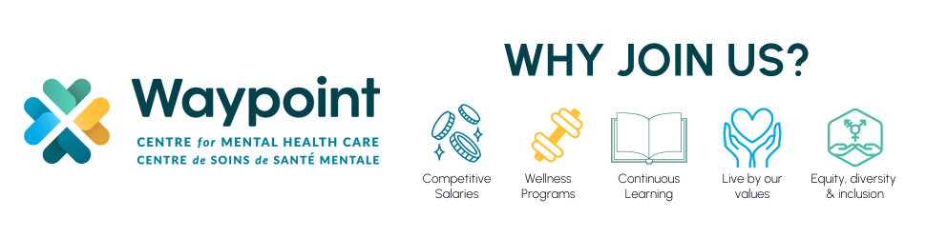

Waypoint Centre for Mental Health Care is a 321-bed academic and teaching hospital that provides specialized mental health, addiction and geriatric care. Located on the shores of Georgian Bay, we serve some of the most complex and disadvantaged individuals in Ontario and are the sole provider of high-secure forensic mental health services in the province.
The Director of Philanthropy is currently seeking a Senior Development Officer, Annual & Mid-Level Giving. The purpose of the position is responsible for leading and growing Waypoint’s annual giving program by developing and implementing strategies that acquire, retain, and deepen donor relationships. The role oversees annual and mid-level fundraising initiatives across multiple channels, including direct mail, digital, email, telephone, tribute and memorial giving, employee and retiree giving, and monthly giving. Working collaboratively with the Major Giving team, the position also supports the development of a strong donor pipeline by identifying and cultivating donors with the potential to increase their engagement and philanthropic support.
Please Note: This position offers a hybrid work environment consisting of in-office and remote work. Office location is 500 Church Street Penetanguishene.
For information about funding incentives for nurses, our enhanced employee referral program, housing, orientation and other employment-related information please follow this link to our employment web page. https://www.waypointcentre.ca/get-involved/join-our-team
KEY ACCOUNTABILITIES:
- Lead Waypoint’s annual and mid-level individual giving program for gifts under $5,000, establishing strategies, annual revenue targets, activity plans, budgets and performance measures to grow donor participation and philanthropic revenue.
- Develop and implement strategies to acquire, retain, renew, reactivate and upgrade individual donors.
- Manage a portfolio of annual and mid-level donors and prospects, using personalized communications, stewardship, solicitation and relationship-building strategies to deepen engagement and increase giving.
- Serve as program lead for Waypoint’s direct response fundraising program, developing an integrated annual campaign calendar across direct mail, email, digital, social and other appropriate channels.
- Serve as program lead for tribute and memorial giving, developing strategies to increase in-memory, in-honour and other commemorative giving while ensuring sensitive and meaningful stewardship of donors, families and honourees.
- Serve as program lead for employee and retiree giving, developing campaigns, engagement opportunities and stewardship strategies that strengthen participation and philanthropy across the Waypoint community.
- Serve as program lead for monthly giving, developing acquisition, conversion, retention, upgrade and stewardship strategies to grow Waypoint’s base of recurring donors.
- Maintain accurate donor and prospect records and ensure solicitation, stewardship, moves management and donor interactions are appropriately documented in Waypoint’s donor database.
- Monitor emerging trends and best practices in annual, mid-level, direct response and individual giving and recommend opportunities for program growth and innovation.
- Collaborate with Strategic Communications & Public Affairs to develop compelling, donor-centred fundraising content and ensure alignment between fundraising and organizational communications.
- Collaborate across the Philanthropy team to support integrated stewardship, events, campaigns and other fundraising priorities.
REQUIREMENTS/QUALIFICATIONS:
- Bachelor’s degree in fundraising, sales, and marketing, or non-profit/volunteer management is required.
- Minimum three (3) years of progressive fundraising experience, with demonstrated success in annual giving, individual giving, direct response fundraising, donor stewardship, or related programs is required.
- CFRE designation and/or current or previous membership in the Association of Fundraising Professionals (AFP), Association for Healthcare Philanthropy (AHP), or a related professional association is preferred
- Experience managing donor or client portfolios and developing strategies to retain, renew and grow relationships is preferred.
- Knowledge of annual and mid-level giving strategies, including donor acquisition, retention, reactivation, stewardship, and donor pipeline development.
- Experience planning and executing integrated fundraising campaigns across direct mail, email, digital, and online channels.
- Strong understanding of fundraising analytics, audience segmentation, campaign performance measurement, and continuous improvement practices.
- Experience using donor databases and fundraising CRM systems to manage donor records, track engagement, and support reporting and analysis.
- Working knowledge of Canada Revenue Agency requirements related to charitable fundraising, receipting, and donor administration.
- Demonstrated commitment to ethical fundraising practices, donor privacy, confidentiality, and responsible stewardship of donor information.
- Strong proficiency with Microsoft 365 and fundraising technologies, with the ability to learn and adapt to new systems and platforms.
- Excellent relationship-building, communication, and stakeholder engagement skills, with the ability to work collaboratively across teams and with donors.
- Willingness to model and promote Waypoint Values (Caring, Respect, Accountability, and Innovation); French/English bilingualism is considered an asset.
WHAT WE OFFER:
- A comprehensive and generous benefit plan including dental coverage, paid holidays, paid vacation days, sick days and extended health benefits
- Participation in the Health Care of Ontario Pension Plan (HOOPP)
- Professional development and mentorship opportunities
- Relocation support program for eligible staff
- Access to Waypoint’s Employee & Family Assistance Program (EFAP)
HOW DO I APPLY?
Waypoint employees apply through the Employee Self-Service portal at https://employees.waypointcentre.ca and external applicants apply to Join our Team, Career Opportunities | Waypoint by close of business (4:00 pm) on September 25, 2026 quoting Job ID WC26-230. Attach your cover letter and resume detailing why you are interested in this opportunity and how you meet the qualifications and key accountabilities specified. Waypoint does not use artificial intelligence (AI) to screen, assess, or select applicants.
